Bylong Valley stands against coal mine

https://thefarmermagazine.com.au/bylong-valley-stands-against-coal-mine/
A tiny community group in the Bylong Valley has won its third-round bout in stopping a 6.5 million-tonnes-per-year greenfield coal mine tearing up fertile farmland.
by Michael BurtSeptember 21, 2021
After a David vs Goliath type battle that has lasted more than a decade, the eight farmers left in the Bylong Valley Protection Alliance (BVPA) are embracing an NSW Court of Appeal decision last week to refuse the Bylong Coal Project.
The decision comes after the Independent Planning Commission (IPC) rejected the project on environmental impact grounds two years ago and the NSW Land and Environment Court declined an appeal for a judicial review in August 2020.
The IPC cited concerns about groundwater impacts and the contribution to greenhouse gas emissions from the project put forward by Korean energy giant Kepco. It also noted the Bylong Valley had a long history of farming, including horse breeding.
NSW Farmers presented its opposition to the project during the 2018 IPC hearing, stating there were unacceptable impacts to a “finite and special agricultural resource.”
BPVA Chair Phillip Kennedy said Kepco can still lodge an appeal in the High Court of Australia.
“They got beaten three to nil in a strong unanimous decision last week and each of the three judges cited a reason why it shouldn’t go ahead,” Mr Kennedy said.
“One would think three strikes and you’re out, but who knows if Kepco will proceed? Such a resounding loss does not look good.”
“What we need is certainty and that’s why we are calling on the state government to extinguish the mining licence and really put it to bed.”
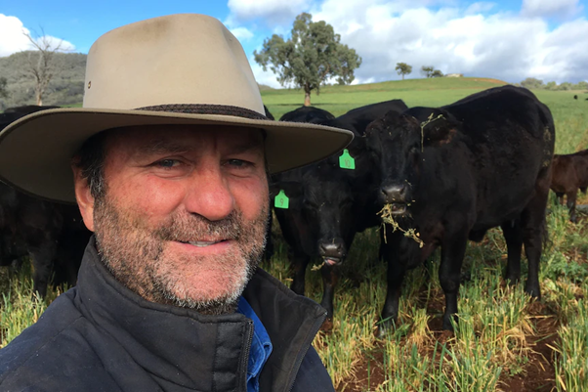“They got beaten three to nil in a strong unanimous decision,’ says Bylong Valley Protection Alliance Chair Phillip Kennedy
Mr Kennedy, who runs cattle and sheep on a 1200-hectare Bylong Valley farm, said Kepco should be encouraged to sell its 13,000 hectare land bank in portions suitable for family farms.
“It should be sold in the manner that it was purchased, and that was mum and dad sized farms. We would not like to see a large corporate come in and buy it all up.”
“There are about eight farmers left along here – they have managed to divide and conquer us – but there is still a tight knit group of us left.”
The BPVA enlisted the help of the Environmental Defenders Office for the legal bouts.
“We had to raise a considerable amount of funds and we would really like to thank to all the people who donated to our GoFundMe page,” said Mr Kennedy. “We could not have done it without them.”
“This was not just about farming and the environment. The Bylong valley is rated as one of the top ten drives in NSW, and the two or three hundred bikers that use it on the weekend would much prefer farmland than a coal mine.”
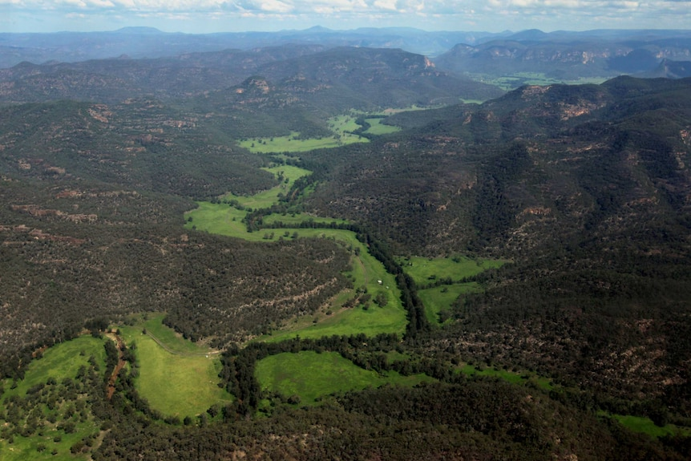The Bylong Valley Way is rated as one of the top 10 tourist drives in NSW. Located near Mudgee in central western NSW, the valley is known for its scenic beauty and fertile agricultural land. (Image: Lock the Gate)
EDO Managing Lawyer Rana Koroglu said they presented testimony from over a dozen expert witnesses and put the latest scientific evidence before the Commission.
“The IPC made its decision based on that evidence, finding that this coal mine is not in the public interest. Two subsequent appeals have thoroughly tested and supported the IPC’s decision to refuse the mine,” Ms Koroglu said.
“We are delighted for our clients – the Bylong Valley Protection Alliance – who have once again successfully argued for the rejection of this mine and defended their beautiful valley. It’s time for the proponent KEPCO to walk away.”
A Kepco representative said the company was considering its next move.
“Kepco is disappointed that the court was not in favour of the project, and will now take some time to review the decision and consider its next steps,” they said.

Bring Bylong Valley back
Third-generation farmer and NSW Farmers Member Peter Grieve, whose farm is in the Bylong Valley, is among those opposed to a coal mine in his region.
Peter, who operates the Talooby Angus cattle stud and commercial herd on 1600 hectares, said the NSW Court of Appeal decision was a “big win” for the tiny BVPA.
“We are not out of the woods yet. While they still have a lease, they can keep coming back with amended propositions to try and get a coal mine,” Peter said.
“They just need to pack up and go home. This project will ruin a heap of country and water. This was once a thriving valley with cattle, lucerne and significant horse studs and we want it back.”
“This coal mine can be finally stymied by the state government at end of this lease, which I believe ends later this year. It’s eleven years we have been fighting this and enough is enough. Let’s get the licence extinguished.”
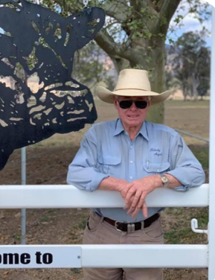Bylong Valley cattle farmer Peter Grieve
Kepco have reportedly spent $115 million to buy properties including a church, the general store, the local public school, and significant private landholdings including historic Tarwyn Park.
“At least nine farmers have left the valley. The shop has been closed since June 30 and that’s the hub of the valley. And the company is refusing to do required building maintenance on the shop and residence.”
While the BPVA has been the driving force, Peter echoed Phil Kennedy’s appreciation of support from those outside the valley.
“We’ve had a lot a support from across the country and the world who have supported us because they were absolutely appalled at the thought of coal mine in this beautiful valley.”

Riled up in Rylstone
A new coal mining battleground has emerged less than 50 kilometres from the Bylong Valley.
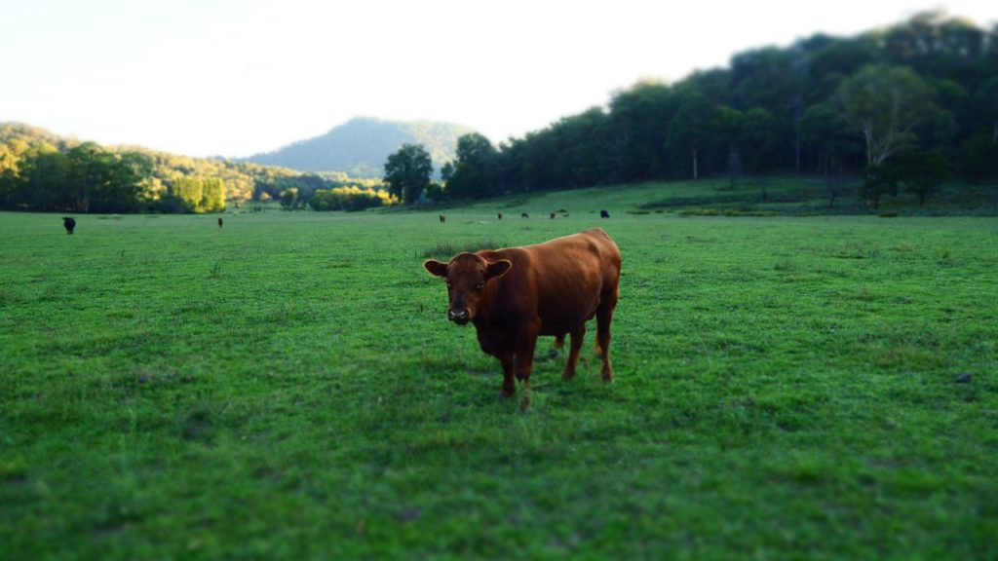The Rylstone valley is also now in the coal mining spotlight
Last June, the state government’s strategic plan for the coal industry identified three areas to the north and east of Rylstone as some of the only areas in the state that would still be eligible for new coal exploration.
The NSW Department of Planning Industry and Environment (DPIE) is now undertaking the first stage of the Hawkins Rumker Preliminary Regional Issues Assessment (PRIA) process to assess whether area around Rylstone, Kandos and Lue is suitable for coal exploration.
The “strategic release areas” make up almost 33,000 hectares of state forest, Crown land and private property.
The DPIE has received more than 1,800 submissions prior to an 18 August deadline, according to the newly formed Rylstone Region Coal Free Community (RRCFC).
RRCFC spokesperson Janet Walk said the vast majority of submissions are against opening up the area Rylstone, Kandos and Lue areas.
In addition to taking submissions online, via email, on paper and via voicemail, DPIE held seven Zoom consultation sessions and more than 90 percent of the participants in the online consultation sessions expressed opposition to the mine.
“During those consultation sessions the message DPIE received from the Rylstone, Kandos and Lue communities was very clear: the Hawkins Rumker PRIA represents the wrong mine in the wrong place at the wrong time,” Janet said.
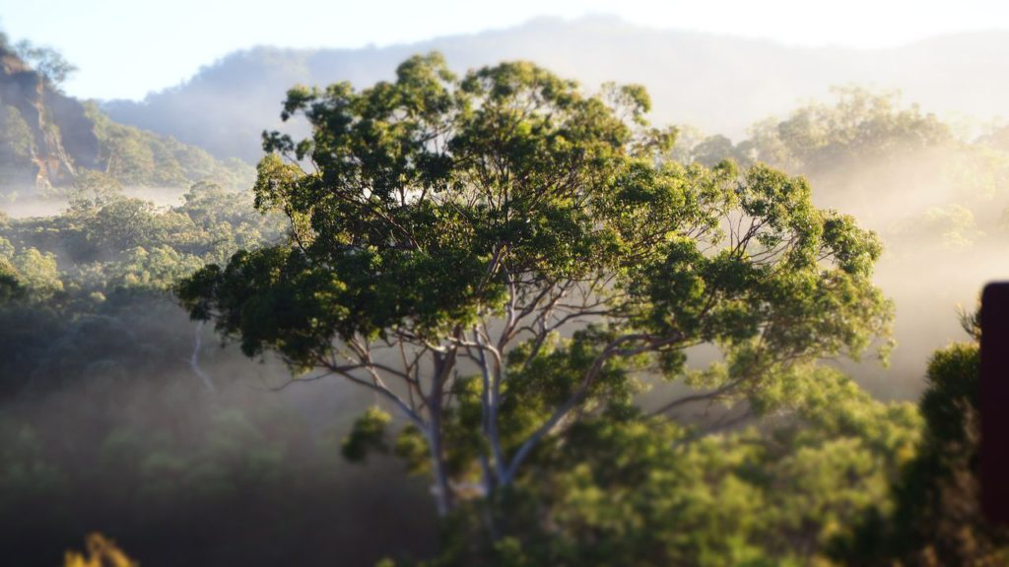The state government’s strategic plan for the coal industry identified three areas to the north and east of Rylstone as some of the only areas in the state that would still be eligible for new coal exploration.
“It’s gobsmacking really. I moved here 25 years ago to purchase a farm and ride horses and now farmers like myself are on the frontline to save our land and water from coal mining like they have had to do in other regions.”
The areas being investigated are Hawkins – approximately 26km east of Mudgee and north of Rylstone; and Rumker – approximately 37km south-east of Mudgee and northeast of Rylstone.
Want to know how farms are where real climate action happens? Read more about a National Farmers Federation campaign here

